Hi hope you are well. Could you make something like this ? [https://vimeo.com/131175203](https://vimeo.com/131175203" \t "blank)  
If so can it be changed to brand it for each customer?   
Thanks so much

Thanks . There are more videos in Vimeo under springday if that helps

What it is , it would be a portal I create for my corporate clients with their logo etc, employees would have their own profile and I upload information, challenges etc

I need a platform where uses can login , have a profile, read info and integrate Fitbit etc

That is what I have at the moment but the uses can't have a profile or integrate Fitbit or interact with it

Like steps etc, with wearable tech devices

Not sure how it's done

If you can integrate with fitbit, Garmin and make sure each individual can have a login, profile, and you can show us how to modify it and brand it , then the job is yours.

Can I then make the platform an app?

I already have someone that does the apps for me , could you let me know the type of platform it would be so I can ask if he can do it? Thanks

Ok please let me know if you can integrate. Yes I meant a mobile app. I have someone that converted my blog to an app

I want a desktop version from you

Yes we need them to access anywhere so web it is

Ok how much more and also what time frame do you need

What do you mean? Examples of what it would look like?

What is the information you can upload from devices? Steps ? And what else ?

I thought you asked what information I wanted from them

Look I would be interested in going ahead and I understand it's a tricky project but if you can say you can deliver it then let's do it.

Yes please , can I also ask you. How hard or easy would it be to modify content

The health hub will be modified fortnightly with new information like articles, videos , exercises etc.

Great. The "blog " part of the site I meant how hard is to modify content

So you understand that the site will have different sections or tabs for me it will be EAT, move, think, learn, and your profile . Under these I will load different information fortnightly. Just like the video I sent you.

I would like the site to have a home page and then they login into it , is this possible ?

Ok great. I will place the order after the 25th December since we are on holidays. Hope this is ok? Or if you like I can pay half now? And have then?

I was just thinking , how will I give each customer their unique access to program. Is it hard to replicate the program for each customer? Ie different logo etc?

Also will they be able to access this on mobile devices? Sorry for all the questions

Ok. Thanks . But if i wanted to give each customer their own " branded " site ( with their own logo) i would need a replica of the site? How would it work? Like a URL?

Sorry I meant the site itself. If a customer (company) not individual wanted to have their logo added to the site. Then I would need to replicate the same site for another customer otherwise they will see another company's logo. Or would it be another page they see only?   
This is to be given to my corporate clients and their employees can access health info .

What it would be is a health and Wellness portal/hub that companies will provide to their staff . We will update the health and Wellness information once a fortnight, it will include information on EAT- recipes, nutritional advice etc, MOVE- exercises, challenges etc, THINK - mindset etc.  
Each user will have their own ability to make their own profile with login and password.  
They will be able to log steps, etc   
The company can also "brand "  
The site with their logo.  
The site can also request an appointment via Skype or phone call with a dr or practioner ( via form or call to us)   
Hope that makes sense

No they add their own user name and password. I can't add their steps or integrate their wearable devices

I can give them user names I suppose but that's it

Tomorrow I will send you mock screen shots of what I want it to look like and features . Would that help

Ok so I made up a mock portal with pics ect. I hope this gives you a better idea.  
I will have more content and proper pics for you.  
The layout is just an example , if you have better ideas please do them. this was so you get a bit of an idea what it is.  
Hope that helps

Are you talking about the wearable devices ie Fitbit ?

Normally what happenes it plugs in via a USB

Have you looked at this   
<https://dev.fitbit.com/au>

Yes, it needs to record their steps. Once they register on the system ( on the fit bit site) it must connect right?

I assumed that API explanation was sufficient

The person is the one wearing the Fitbit. So it needs to synch to their device and the site

Will it help if I speak to Fitbit? If you can't do it please let me know. I was very clear I needed this, since I already have a site without it. What will help you?

No i never said user needs to post problems. I said we post challenges ( like step challenges, exercise challenges ) and they record it when completed

And I said I needed the step and devices to be synched

Anyway there is no point going back and forth. What can you do

And the rest I sent you? Can you do this? Still have a link to the wearable websites at least. I am a bit disappointed since I already have a website clients can login so I wanted the wearable device features. How will you modify my quote? Since I will need to do this again!

Can you let me know what you can do on your this site? What I sent you?

Can you make this software with the other features I sent you , and make sure it can be mobile friendly also. ?

Is it possible to be able to make an app of this software cause i need to know now if this is not possible

An app from the web based desktop version

Of the web

What I mean is have the desktop version and the option of the app also

No ,just the web based and the mobile app

Same features. Is it easier just to convert the website to an app? I did this before

Ok can you give me the platform the web based development we are doing ? So I can give it to my app guy?

In the meantime please get started with the rest. Can the user have their email and individual password feature?

Great. Let's make it as best as we can

Hi the pictures on the side should be underneath the welcome. And the side panel should have a picture and then the what's new underneath it  
Please see pic attached

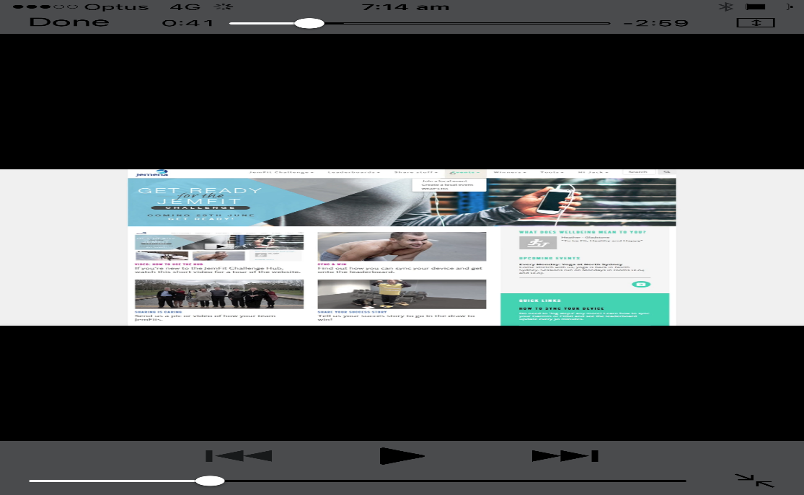

Can it be anywhere? Which one do you recommend?

So I need to give each client a different URL when I custom make their domain name with different logo

Sure send it to me the remaining and I will send you tomorrow some content

Also please look at [www.completecorporatewellness.com.au](http://www.completecorporatewellness.com.au/) for reference of colours for site . Thanks

Not sure what you mean. Possibility arose about what?

I am still on holidays so not on the computer much. have done so now.  
I have a few questions.  
1) Can the user have "forgot password" option?  
2) Do I have control of who joins , take away login rights etc  
3) Can I see how many users have joined my site?  
4) Will it have a desktop icon?  
  
I will send you the photos I want in the front page, and in site soon.   
Thanks

please see what I want the front page login to look like. let me know what you need in terms of picture size etc

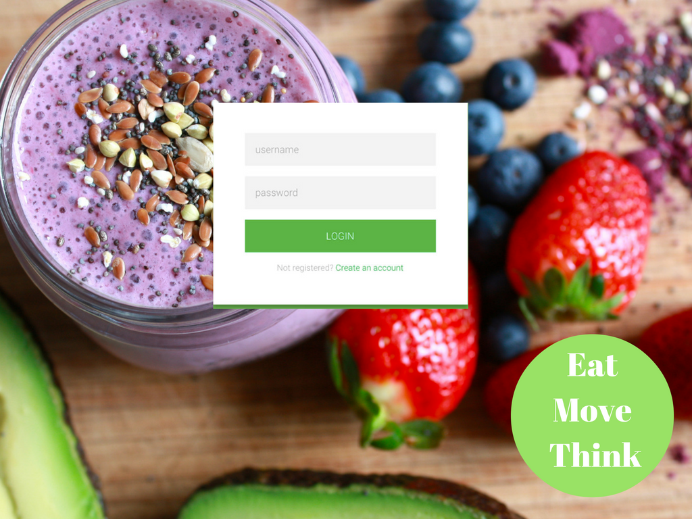

Don't worry about that, it was for my app person

Sure I'll do this today. What size do you prefer?

Please see links to the photos I would like in   
1) Home page Login - <https://www.dropbox.com/s/f86iyxw74zjga2n/smoothie.jpg?dl=0>  
2) Banner of home page - <https://www.dropbox.com/s/wujowrgt6owkfgz/couple_exercise_water.jpg?dl=0>  
3) Within Eat - <https://www.dropbox.com/s/inazxukgvyyy8k6/iStock_68584407_XXLARGE.jpg?dl=0>  
4) Move- <https://www.dropbox.com/s/tyugo0srqkdlnxp/iStock_90742145_SMALL.jpg?dl=0>  
5) Think - <https://www.dropbox.com/s/my8356uskm0vqo3/meditation.jpg?dl=0>  
6) Learn - <https://www.dropbox.com/s/s3l41v5secoc4n9/memberlogin.jpg?dl=0>  
  
If you need more please let me know. Can you send me an update of it, some screenshots when you are done?  
Thanks

Not sure what you are showing me though. I would like the login page to look how I designed it. With the green form.  
2) the tabs can it be a different colour? Maybe the blue of me logo with white writing

Please see [www.completecorporatewellness.com.au](http://www.completecorporatewellness.com.au/) for colours

The pictures haven't been changed yet have they ? Apart from banner

What mockup? The only mock up I sent you was the login page . The smoothie and the login . The rest was a sample of the layout

Would you like  
Me to send again what I want it to look like   
From  
1) login page  
2) home page  
3) photos and tabs?

Ok maybe I don't understand what you sent me. I'm on my mobile let me  
Look  
At it on computer and I will get back to you

I have done a mock up of what the site should look like, of course it is not to scale and not arrange exactly, but you can see the colours is vibrant, and clear colourful pics. Can you do this? Also who will I see more of the functionality of it all? Are we still on schedule?  
Thanks

And I had sent you the screen shots of the site inside with all the features it should have, please follow same colours as above.   
This is a mock up of the site inside with the different features, I sent this to you a while back.  
Please let me know if this is not clear.   
Thanks